About the module: Key points for students
You will be provided with pre-populated spreadsheets to complete the tasks for this unit.
Basic formulae
Formulae are entered by clicking on the cell where the formula is required and then typing.
All formulae begin with an equals sign = .
Cell references (such as A1, B2) are used to identify the cells containing values to be used, and the operators +, -, * and / are used.
The formula in a cell can also be edited by selecting the cell and then clicking in the formula bar.
Cell references
A relative cell reference will change when it is copied or replicated to another cell.
An absolute cell reference is created by adding a dollar sign $ in front of the column reference, row reference or both. This fixes the reference so that it does not change when it is replicated.
Functions
Functions are pre-programmed into spreadsheets to enable longer and more complex calculations to be performed easily. Functions always begin with an equals sign = followed by the function name.
The functions that you will use through this unit include:
Function | Use
SUM | Adds up the values in a range of cells.
AVERAGE | Works out the average value of a range of cells.
MAX | Finds the largest value in a range of cells.
MIN | Finds the smallest value in a range of cells.
IF | Is used to return one value if something is True and another value if something is False. It is used in decision making.
COUNTIF | Counts how many cells in a range contain a specific value.
COUNT | Counts the number of cells in a range that contain a number.
COUNTA | Counts the number of cells in a range that contain a value (text or a number).

Formatting
Formatting is used to make a spreadsheet easier to read and to highlight important information and values. The formatting tools are found in the ribbon.
Conditional formatting will automatically change the appearance of a cell depending on the value it contains.
In Excel, conditional formatting is applied by selecting ‘Conditional Formatting’ and ‘Highlight Cells Rules’ from the ‘Home’ tab.
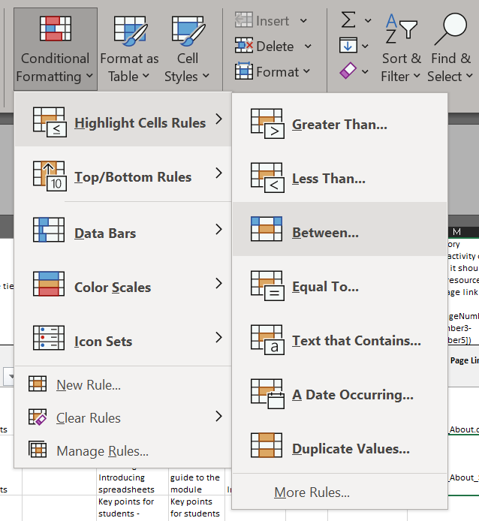
Graphs and charts
Graphs and charts can be created to give a visual representation of the data in a spreadsheet.
In Microsoft Excel, select the data on the spreadsheet, go to ‘Insert’ and then choose the type of chart you require from the ‘Recommended Charts’ drop-down list.
Goal Seek
Goal seek allows you to see how changing one value in a formula affects another.
To use Goal Seek, go to the ‘Data’ tab, click on ‘What-If Analysis’ and select ‘Goal Seek …’.

